Materials linked from the May 25, 2021 Budgets & Fiscal Planning Committee meeting.

BUDGET NARRATIVE
Organizational Leadership Certificate

Please provide details on Personnel, FTE directly supported by the budget and reallocation of personnel if appropriate.

Personnel:

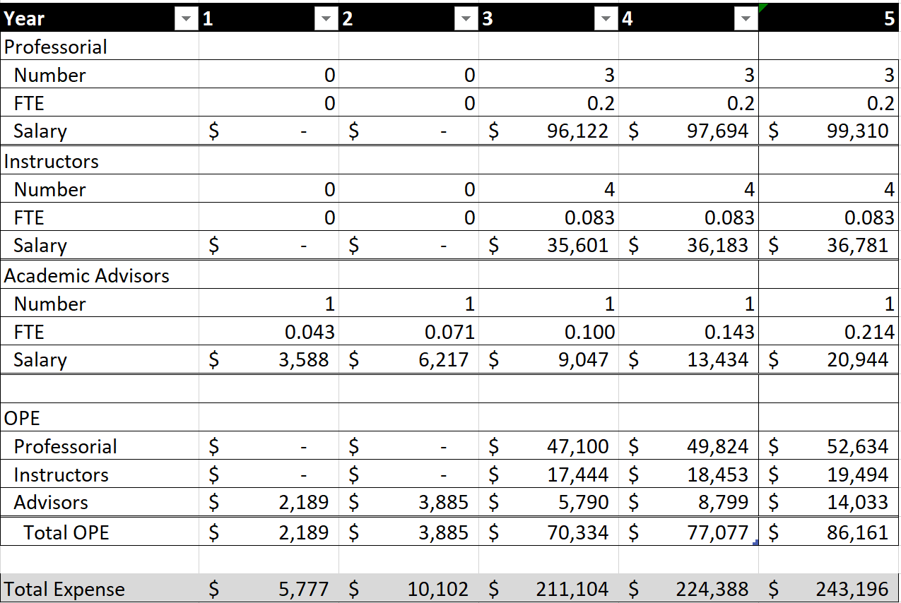

NOTES:
- Projected enrollment can be absorbed into existing course offerings in years 1 and 2 – no added instructional resources are required.
- Starting year 3, we would need to add one section of each of the seven courses. We project steady-state to be achieved in year five.
- We estimated the FTE for academic advising based on the university goal for student-to-advisor ratio of 350:1. Thus, the total headcount for a given year was divided by 350 to achieve the advisor FTE.
- We presumed a 3% increase in salaries per year.
- We used OPE rates from the Research Office web site, and extrapolated those rates for future fiscal years.

Other Expenses:

None: The college has a marketing and communications unit that maintains our web site. There will be no additional expenses associated with adding the certificate to our existing web pages. We do not envision creating physical collateral – all information pertaining to the certificate will be in electronic form.

Resources: Please identify and explain sources of all funds and highlight whether they are recurring or one time.

Current Budget: E and G funds and e- campus revenue will be used to support the new program and cover expenses.

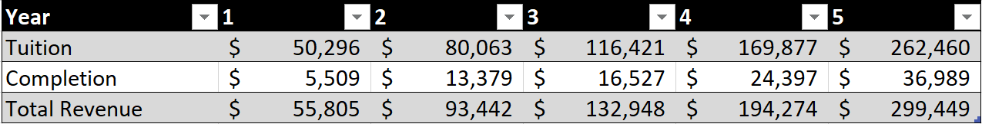

NOTES:
- We assume the student mix will be 2/3 eCampus (rate of $150 per SCH) and 1/3 on-campus (rate of $190 per SCH from budget model). Thus, we used $163.33 per SCH for tuition revenue projections. We increased tuition by 3% per year.
- Completion bonus is estimated at 1/5 of the budget model allocation of $3935 per student = $787 per graduate.

Tuition remission support (for Graduate Programs only): Graduate school, Laurels and Block Grant awards and other Grants – not applicable.

Other: Describe other resources including endowments and any special appropriations.

Finally: Show that Expenses = or are less than Resources
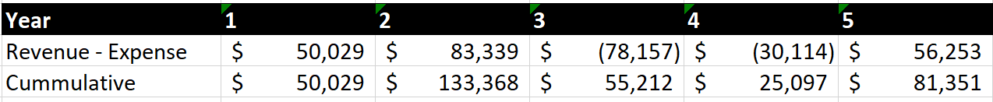
Being able to absorb the first two years of enrollment into existing slack enable us to accumulate revenue to offset the losses in years 3 and 4. When steady state is achieved in year 5, the program will generate revenue to the college.

Other Payroll Expense (OPE) Information and Estimated Rates | Research Office | Oregon State University

